Free Materials To Help Teens Quit Vaping and using Tobacco
Order Form
Available from the PA Department of Health
Ship To: | Name  Company Name  Street Address  City, State, Zip Code  Phone Number  Email | ________________________________________________________________________________________________  ________________________________________________________________

Posters | Small  8.5”x11” | Large  11”x17” | Total
Teens Jumping
Piggy Bank
Vaping Cigarette
Young Man Wallet
Jogging Girl
CDC Brain poster
All-poster pack
(6 pack)
Total
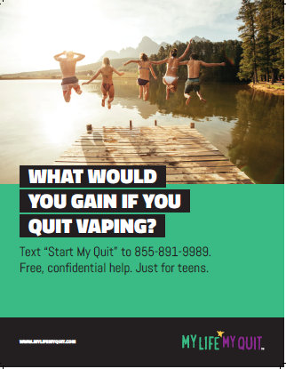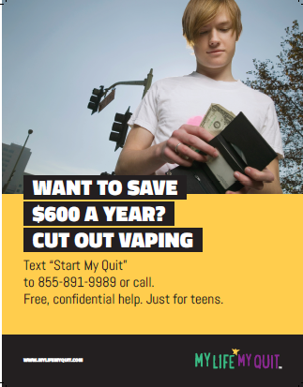
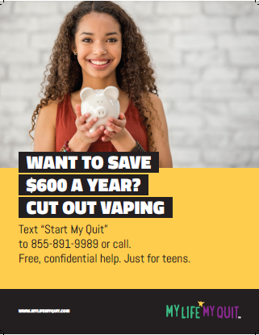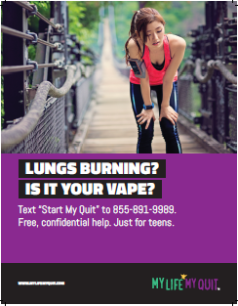
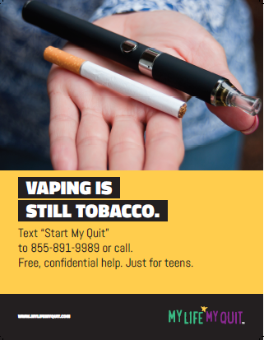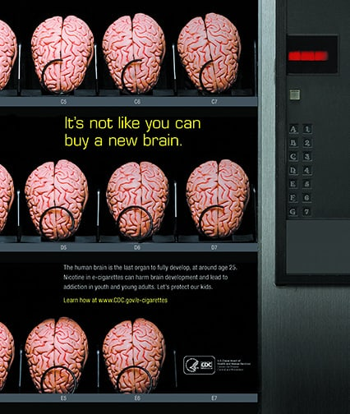

MyLifeMyQuit | 3.5”x8.5”
Rack Card
Total
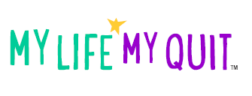
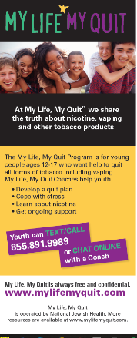
To order, email this form to:
RA-DHPAFREEQUITLINE@pa.gov

