

Dear Sir or Madam

In December 2022, the Division of Tobacco Prevention and Control mailed these [instructions](https://www.health.pa.gov/topics/Documents/Programs/Tobacco/CIAA%20myPATH%20Fact%20Sheet%20and%20Instructions.docx)

to establishments with Clean Indoor Air Act (CIAA) smoking exceptions. If you did not complete the

process as instructed, or, if you received a CIAA smoking exception renewal denial letter due to not

correctly entering your sales information into myPATH and need to complete an amendment as part of

the appeal process, please see the directions below on how to complete an amendment to the myPATH

information you have previously submitted.

To complete an amendment of your myPATH filing in relation to your Clean Indoor Air Act

(CIAA) smoking exception, please follow the steps below.

1. Log into your myPATH account at <https://www.mypath.pa.gov/_/>
2. Under the Sales and Use Tax account select > View Returns and Periods

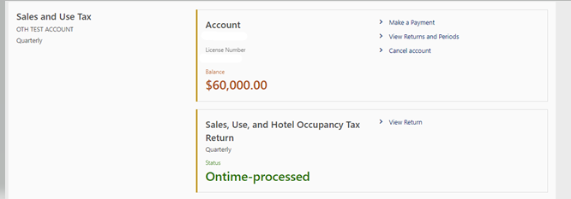

1. Select View Return hyperlink listed with the applicable period from the list of returns

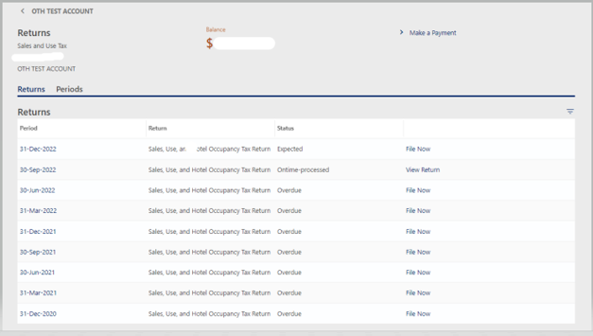

1. If CIAA sales information WAS NOT previously submitted for the monthly, quarterly, or semi-annual filing period you selected in step 3, the CIAA boxed hyperlink circled in red in screenshot below WOULD NOT be displayed and you would need to continue with step 5 and complete an amendment to enter the missing CIAA sales information.

If CIAA sales information WAS previously submitted for the filing period you selected in step 3, the CIAA boxed hyperlink circled in red in screenshot below WOULD be visible, letting you know you previously did enter CIAA sales information for that monthly, quarterly, or semi-annual period. You WOULD NOT need to complete an amendment for this period, *UNLESS* you need to edit the CIAA sales information you previously submitted for that month, quarter, or semi-annual period. If this is the case, proceed to step 5.

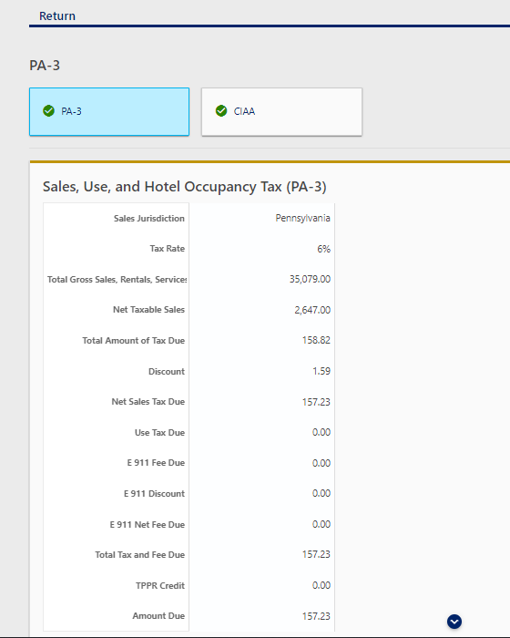

1. Select the “Amend” button listed below

1. Select “Yes” to *Do you have Pennsylvania sales to report?*

Select Yes to any local jurisdiction if applicable

Select “Yes” *Are you including the Clean Indoor Air Act Schedule?*

Select “Yes” to *Are you claiming any Tax Paid Purchases Resold (TPPR) credits?*  if applicable

After you have answered all of the questions select “Next” at the bottom right hand of the screen

1. If applicable, adjust your Taxable Sales

Select “Next” at the bottom right hand of the screen

1. Select the type of establishment requesting the exemption from the drop down

Enter the taxable and non-taxable sales figures

Select “Next” at the bottom right hand of the screen

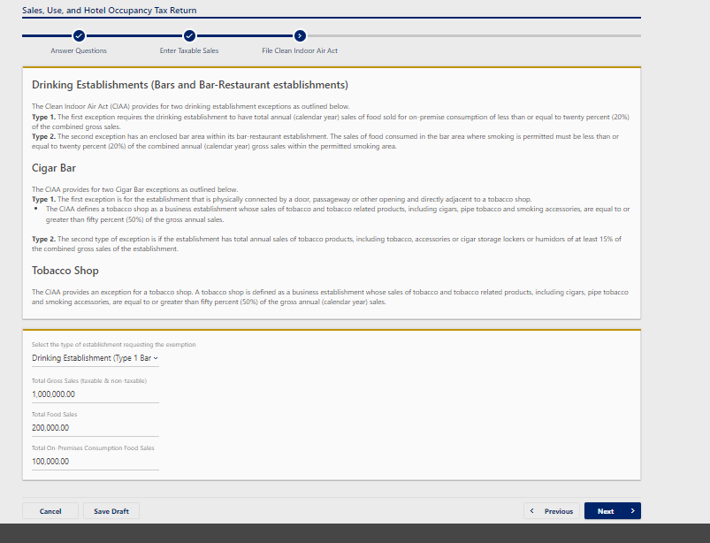

1. Confirm all information is correct on the review screen

Select “Next” at the bottom right hand of the screen

1. If a payment is due at time of amendment select from the options listed below and select submit when completed

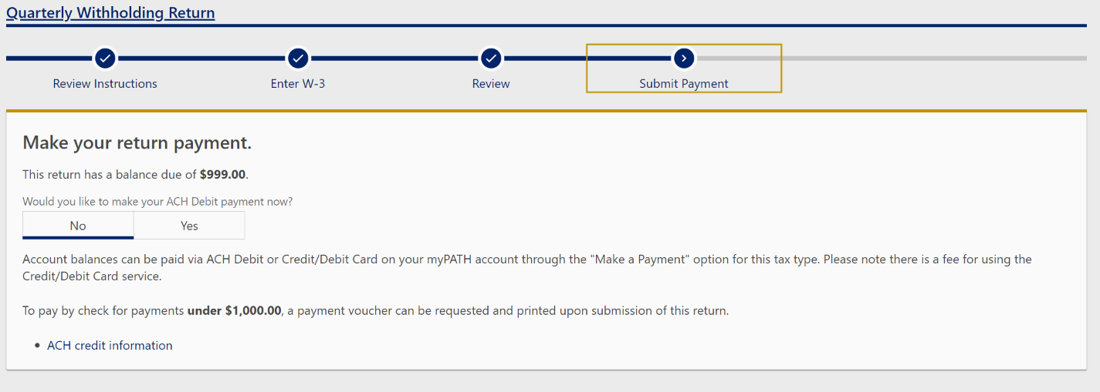

Please contact the Division of Tobacco Prevention and Control if you have any questions.

Thank you.

Division of Tobacco Prevention & Control

625 Forster Street | Room 1032 H&W Bldg | Harrisburg, PA 17120 | 717.783.6600 | F 717.214.6690 | www.pa.gov