**Changes to Reporting Sales Information for your**

**Department of Health (DOH) Clean Indoor Air Act (CIAA) Exception**

In 2023, the DOH will review sales and use tax data submitted to the Pennsylvania Department of Revenue through myPATH, the Department of Revenue’s new online portal that allows electronic filing of returns, payments, available at <https://mypath.pa.gov/_/>. Sales and Use Tax returns and other services will be moving to myPATH. Beginning in late November 2022, e-TIDES will be retired, meaning it will no longer be the online resource for electronically filing return, making payments, and renewing licenses. E-TIDES retirement timeline has been published: <https://www.etides.state.pa.us/Instructions/RetirementTimeline.htm>.

To ensure taxpayer information remains secure and to ensure that only those authorized to access this data on myPATH, we will not be converting existing e-TIDES User IDs and Passwords (i.e., e-Signature account credentials) to myPATH. Existing e-TIDES users will be required to create a myPATH logon to transition their accounts to myPATH. Refer to the Department of Revenue’s website at [revenue.pa.gov](https://www.revenue.pa.gov/Pages/default.aspx) and visit our [myPATH Information Page](https://www.revenue.pa.gov/OnlineServices/mypath/Pages/default.aspx) by going online to [www.revenue.pa.gov/mypathinformation](http://www.revenue.pa.gov/mypathinformation) for more information.

How to enter sales data into myPATH for CIAA purposes:

1. Access the online myPATH system <https://mypath.pa.gov/_/>
2. Login to myPATH. If you do not have an account, click the “Sign Up” under the log in section to set up an account
3. When completing the Sales and Use Tax Return, select Yes to both of the following questions:
   1. “Do you have Pennsylvania sales to report”
   2. “Are you including the Clean Indoor Air Act Schedule”
4. You will then have the ability to enter the CIAA schedule. If you have local taxes to report, select Yes for those jurisdictions. You must enter your sales information on screens prior to the CIAA schedule for DOH to have access to the information. See helpful screenshots with directions below (steps 1-7).

**myPATH CLEAN INDOOR AIR ACT SCREENS WITH DIRECTIONS**

1. Enter Yes to “Do you have Pennsylvania sales to report” and select Next

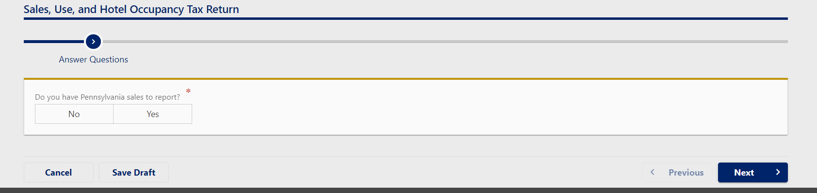

1. Select Yes to any local jurisdiction tax if applicable, Yes to “Are you including the Clean Indoor Air Act schedule, Yes to “Are you claiming any Tax Paid Purchases Resold (TPPR) credits” if applicable and select Next

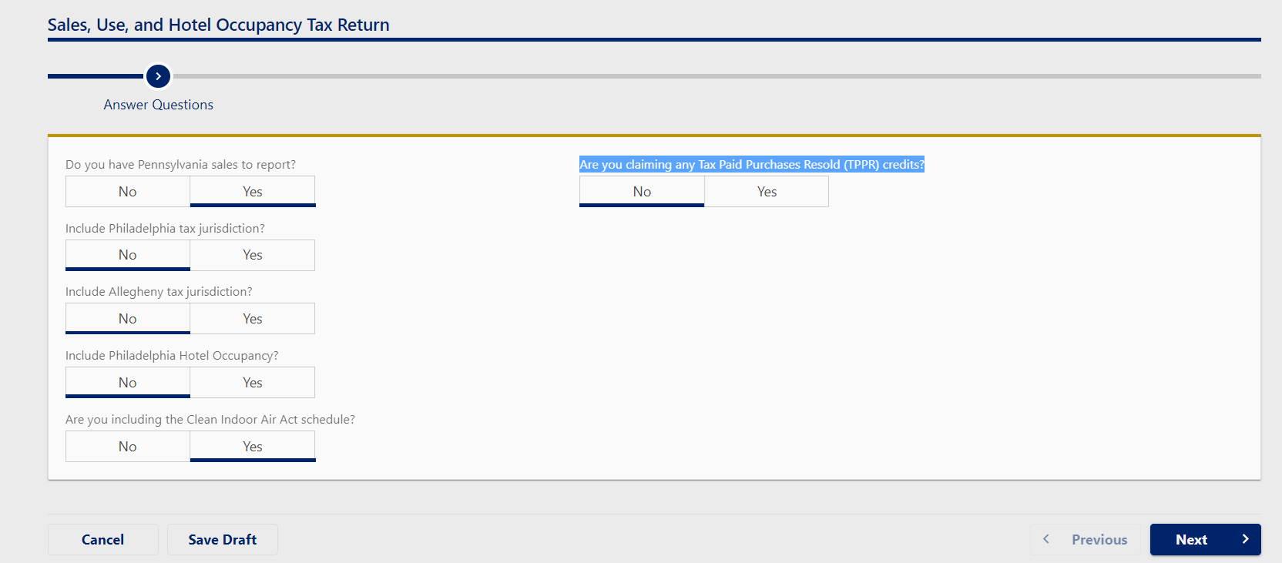

1. Enter Pennsylvania (Allegheny, Philadelphia, & Philadelphia Hotel Occupancy when applicable) Sales, Use, and Hotel Occupancy (PA-3) tax information and select Next

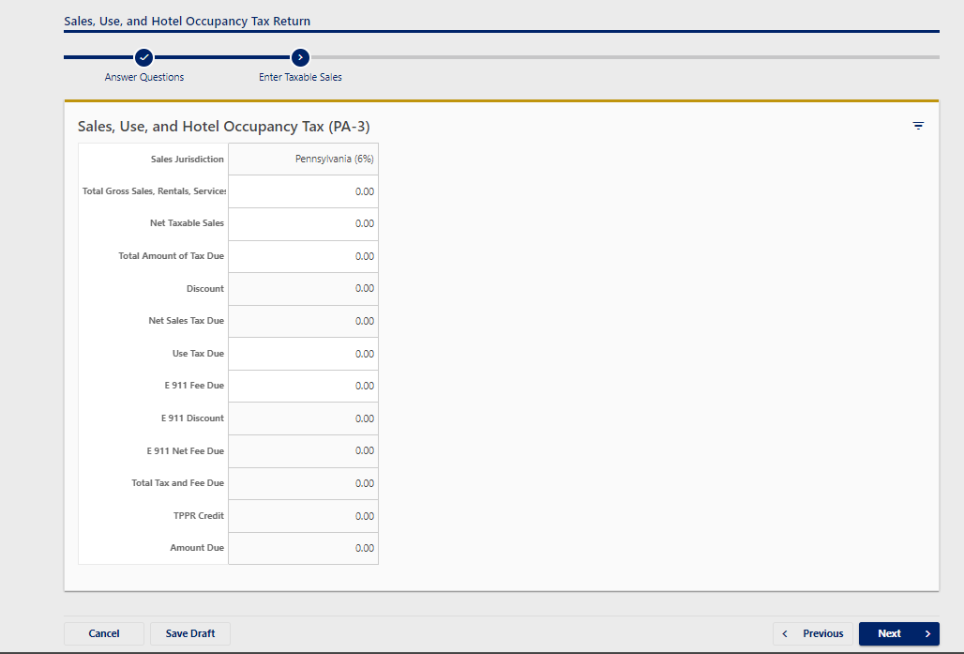

1. Select the type of establishment requesting the exemption from the drop down at the bottom of the screen and select Next

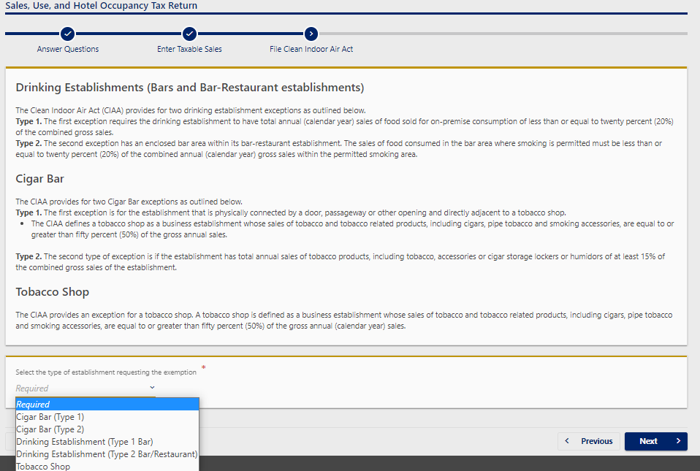

1. Once the establishment type has been selected, please enter requested sales information and select Next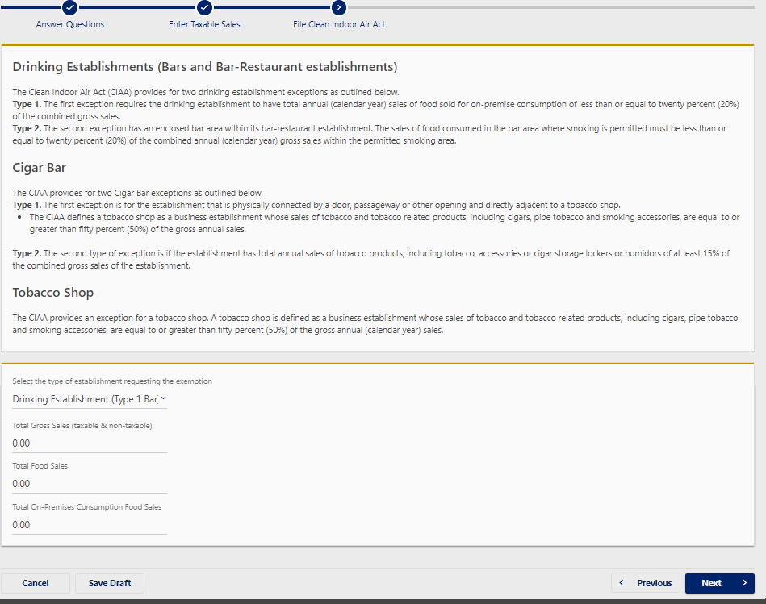
2. Review the Sales, Use and Hotel Occupancy Tax return information and select Next to payment options

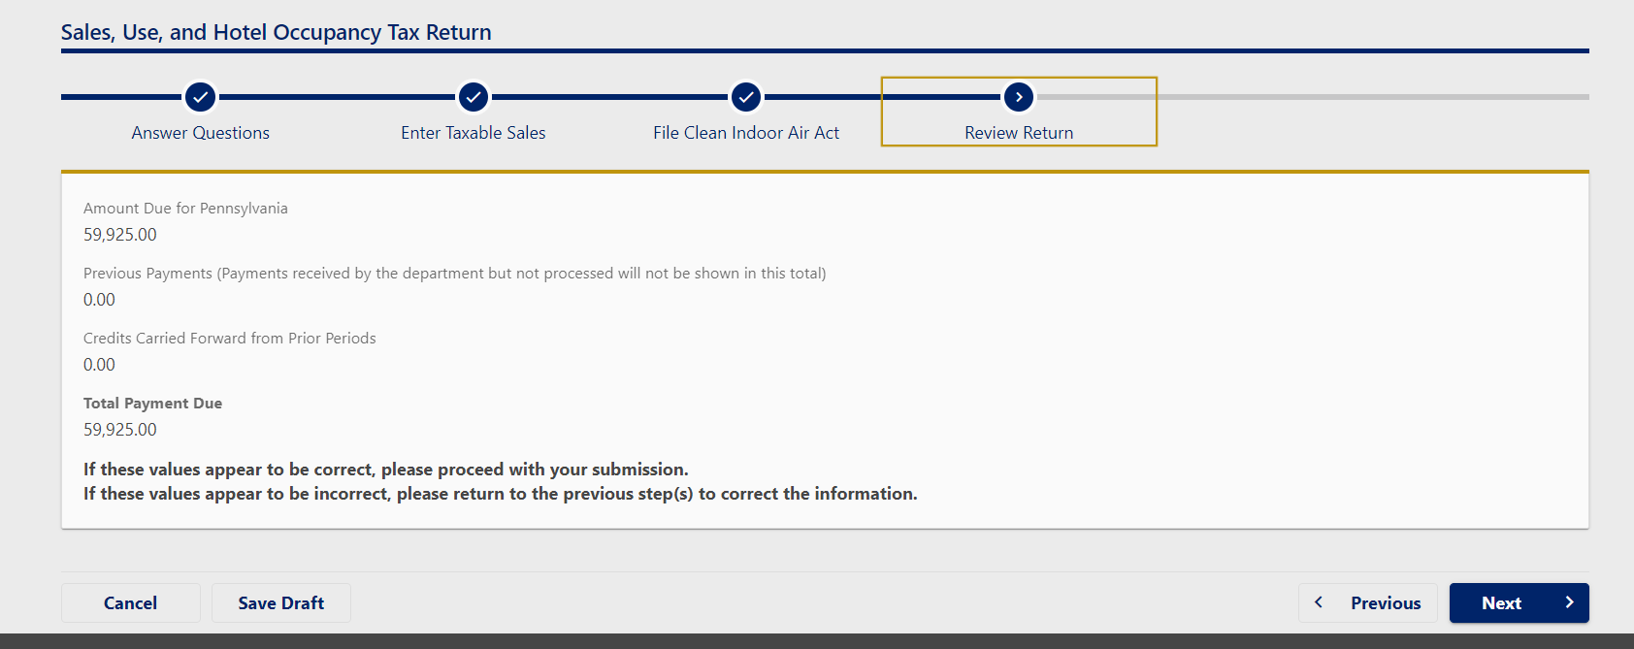

7.a. If you select no for ACH Debit payment, submit the return in the bottom righthand of the screen.

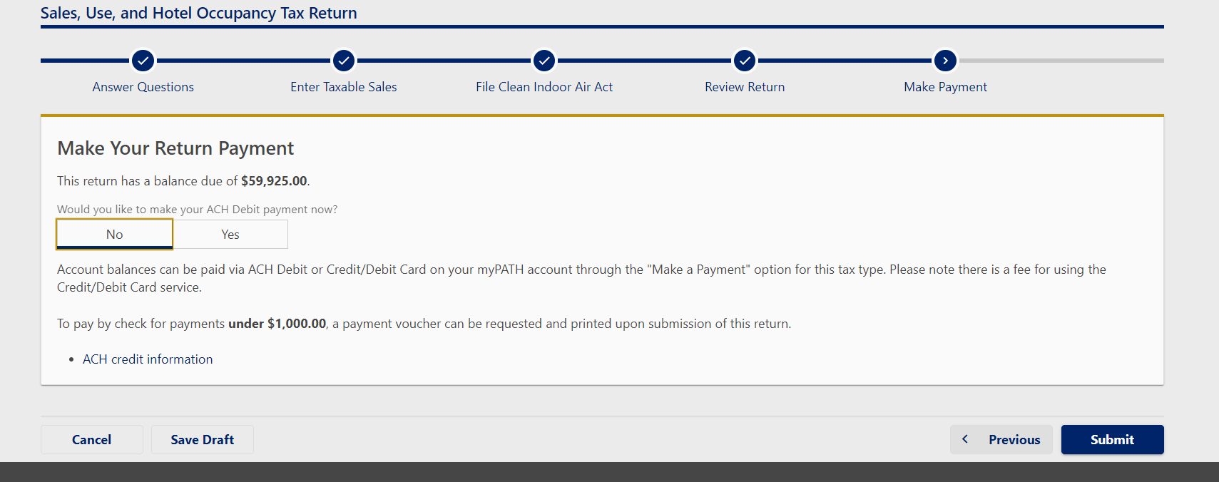

7.b. If you select yes for ACH Debit payment enter the banking information and submit the return in the bottom righthand of the screen.

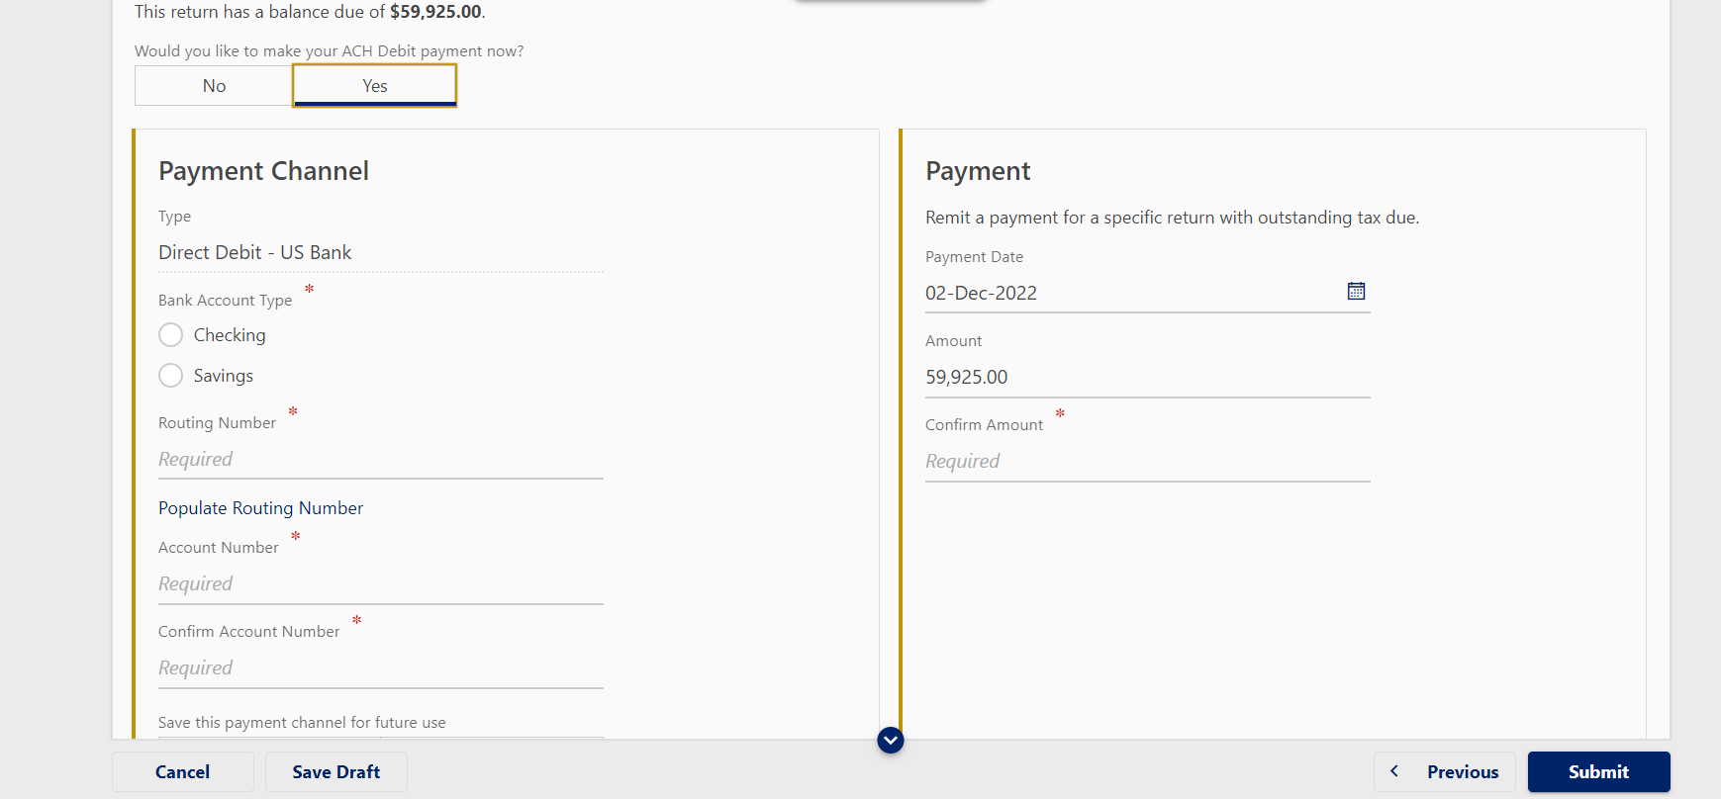

If you have any questions or require additional information, please contact:

Division of Tobacco Prevention and Control

Pennsylvania Department of Health

625 Forster Street, Room 1032 Health & Welfare Building

Harrisburg, PA 17120

Phone: 717-783-6600

Email: RA-CIAA@pa.gov